TITLE FOR EXTENDED ABSTRACT OF i-IDeA 2025

(TIMES NEW ROMAN, 18 FONT SIZE, BOLD, ALL CAPS, CENTERED)

Author’s Name and Surname¹, Author’s Name and Surname² (12 font size)
¹Affiliation 1
²Affiliation 2

*Corresponding author: abc@uitm.edu.my

Abstract: Abstract should be written with 12 font size, Times New Roman, single line spacing. Summarize in this section the introduction, problem statement, objective, methods, findings and conclusions. The length of the abstract should not be more than 350 words.

Keywords: This section should contain maximum 5 words separated by commas.

GENERAL GUIDELINES
The extended abstract must contain the following sections: abstract and keywords, introduction, methodology, findings, conclusion, and references. Section can be named differently and subsections can be included.

The extended abstract shall be written in font Times New Roman, single line spacing and 12 font size. The extended abstract should contain a minimum of 3 pages and a maximum of 5 pages. Extended abstracts can contain figures, tables and/or images which are not included in the word count. The references are not included in the word count as well. Page format should be A4 page size with margins 2.5 cm wide from the right, left, top and bottom. Pages should not be numbered.

In-text citations are included when refer to, summarize, paraphrase, or quote from another source. For every in-text citation, there must be a corresponding entry in reference list. APA 7th Edition in-text citation style uses the author's last name and the year of publication, for example: (Field, 2005). For multiple authors, use the first author's last name followed by the abbreviation et al., for example: (Burke et al., 1999).

Supporting figures, tables and images of the results (no more than three figures and three tables) may be included in the extended abstract.

All the tables, images and figures should be centered. Figures and images should be bordered and numbered (see Figure 1 for an example) and figure headers should be placed under the figure or image; as for the tables, they should also be numbered (see Table 1 for an example) and the table header should be placed at the top. References (if any) of the tables, figures and images should be presented right under the tables, figures and images.
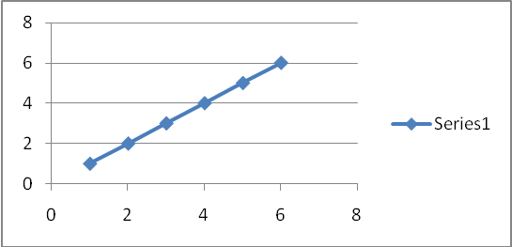

Figure 1. Caption

Table 1. Caption
Sample | Lable | K (min ⁻¹)

INTRODUCTION (Times New Roman, 14 font size, bold, all caps)
The introduction section should (1) present the scope and objective of the paper and state the problem, (2) briefly review the pertinent literature, (3) describe the methods, and (4) provide an overview of the main results of the work.

METHODOLOGY
The methodology must be clearly stated and described in sufficient detail or with sufficient references. The author shall explain the research question, describe the research framework, and the methods applied in detail. It should be furthermore highlighted why the research question is relevant to theory and practice, and why the chosen method(s) are suited for the problem.

FINDINGS AND DISCUSSIONS
The findings and discussions are described in detail in this section.

CONCLUSION
Conclusion should include (1) the principles and generalisation inferred from the results, (2) any exceptions, problems or limitations of the work, (3) theoretical and/or practical implications of the work, and (5) conclusion drawn and recommendations.

REFERENCES
References should be listed in alphabetical order and presented in a format according to the APA Style 7th Edition. (Refer: https://libraryguides.vu.edu.au/apa-referencing/7GettingStarted).
Examples:-

(Journal Article)
Ruxton, C. (2016). Tea: Hydration and other health benefits. Primary Health Care, 26(8), 34-42. https://doi.org/10.7748/phc.2016.e1162

(Book)
Jani, A. M. M., Yazid, H., Habiballah, A. S., Mahmud, A. H., & Losic, D. (2015). Nanoporous Alumina: Fabrication, Structure, Properties and Applications (Vol. 219): Springer.

